SURVEYING EQUIPMENT
Make sure the surveying equipment you will borrow equipment is reliable and in good working order. To ensure this a two peck test must be carried out each time you borrow a level.

Equipment included a number of surveying instruments. A set of instruments that you need to finish the projects, can be borrowed from the Surveying Department

Automatic level
A high-grade levelling instrument with automatic horizontal adjustment of the line of sight, erect image with a horizontal circle of 360° or 400 gon. The level has a large sight and a very short target range. The stable design guarantees accurate and reliable measurements.
The large ribbed control buttons simplify the adjustment of the instrument. The apparatus is watertight IP57 and vibration resistant (ISO 9022-33-5). The automatic level has a magnification of 30, a focus to up to 0.8 m Accuracy per km is about 0.8 mm.
Accuracy single measurement with 30 m aim distance is about 1.2 mm.
Adjustment with bubble level 10’ / 2 mm.
The compensator is air damped. The meter is supplied in a case in which the instrument can be stored shock proof.
Surveying equipment www.eijkelkamp.com
By using a field umbrella
the obstructing glittering during
levelling is avoided.
The sight provides a clear
erect image.
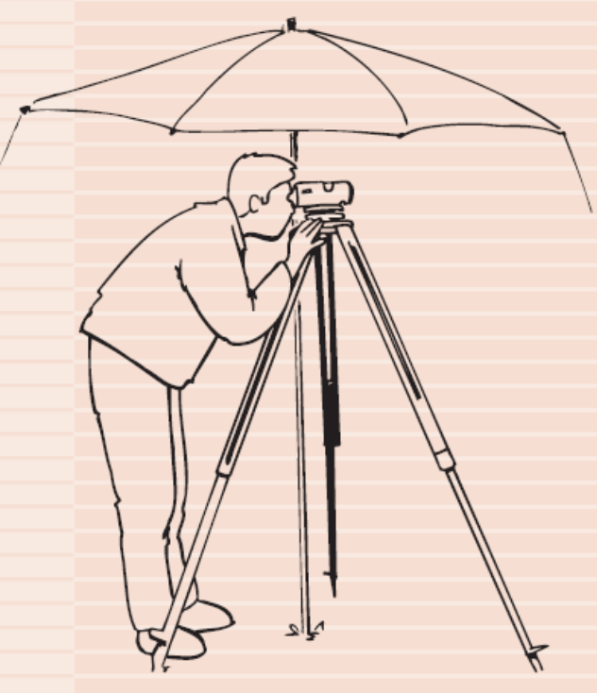
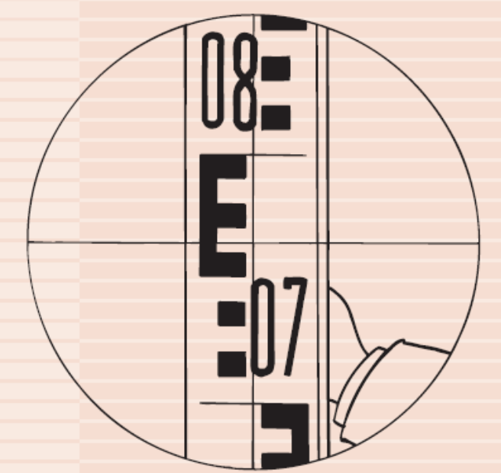

17.06 Automatic level NAN-2020
Level with automatic horizontal adjustment of the line of sight, an erect figure and a horizontal
circle of 0 - 360° or 0 - 400 gon. Stable design for accurate and reliable measurements.
The large ribbed control buttons simplify the adjustment of the instrument. The instrument is splashproof and vibration resistant. The automatic level has a magnification of 20 and a 32 mm objective, a focus to up to 0.6 m
and a mm estimate up to about 60 m and a cmestimate up to 250 m, the tolerance per km is about 2.5 mm. The compensator is magnet damped.
After the instrument has been set almost horizontal the line of sight is carefully levelled using the automatic compensation mechanism. The instrument is supplied inclusive aluminium carrying case.
17.07 Levelling staves and accessories
The program includes two levelling staves, a folding levelling stave made of wood with a synthetic cover with E-graduation in cm and an overall length of 4 m, and a light telescopicp aluminium levelling stave with a graduation in cm and an overall length of 5 m. A light metal tripod with three extendable legs is optionally available for the levelling staves as well as a carrying bag for the telescopic levelling stave.
17.08 Ranging poles and accessories
The program also contains various ranging poles with synthetic cover. The ranging poles are made of wood or steel and have a red and white color division every 50 cm and are fitted with a heavy steel point. Optionally available is a carrying bag for the dismountable ranging poles and a ranging
pole tripod. The ranging pole is secured with a clamp strap and ball-and-socket joint. Vertical adjusting is done using a hold-on staff bubble.
17.10 Double pentagon prism
The pentagon prism square with two prisms of 90° and 180° and a large field of vision, base area mirrored for slope. See through location between both prisms with yellow filter.
17.11 Ground plate
Strikingly colored ground plates for stable positioning of the levelling staves.
17.12 Field umbrella
Umbrella for protecting of the level from obstructing light. Large diameter with carrying bag, dismountable poles and guy ropes.
17.20 Measuring tape
Measuring tape holder with synthetic or stainless steel measuring tapes for distance measuring are supplied in various lengths. All measuring tapes meet the EC-regulations class II regarding tolerance, with an accuracy of approximately 2 mm on 10 m.
17.21 Measuring wheel
Precision measuring wheel with folding grip for distance measuring in the field. The counting mechanism is shockproof and fitted over the measuring wheel. The meter can be calibrated and has a measuring range of 9999.99 m and can be read-out in cm. The tolerance is below 0.02%. The counting mechanism is driven without vibrations. The measuring wheel is supplied inclusive a case.
17.16 Tri-partite aluminium ruler
The aluminium ruler is used for accurate measuring in mm of the planeness of bare surfaces such as asphalt, concrete, gravel, floors of sports accommodations, etc.
The aluminium ruler comes in three parts and is supplied inclusive measuring wedges and carrying bag. The overall length measures 3 meter, the range is 1-20 mm and the accuracy is 0.3 mm.
17.95 Research-set for surveyors
A complete set for straightforward surveying measurements (height, distance, slope and direction).
17.25 Abney hand level
Hand level, arc devided to single degrees (+/- 90°) and in gradient scale, vernier reading 10 minutes.
17.27 Clinometer
Lightweight clinometer with an easily readable scale. The optical scales have a graduation from 0-90° and from 0-150°. Direct reading in 1° or 1% and estimate in 10 minutes or 1/5 of 1%.
17.32 Compass
Compass, usable for all 5 inclination zones, with a highly resistant case, which offers a strong protection to the capsule. With cm scale and sighting line of 11 cm when opened. The underlying mirror allows very simple sighting with a high accuracy of 1°. The needles are rotating on a sapphire bearings in antistatic fluid. With adjustable declination scale.
17.34 Height meter
Liquid damped height meter. Reading accuracy: at a distance of 15 m: measuring range 0-35 m, interval 0.25-0.5 m: at 20 meter: measuring range 0-50 meter, interval 0.25-1.0 m.
17.52 Global Positioning System, GPS 76
Accurate navigation in the field applying the Global Positioning System (GPS). A navigation system that uses satellite signals. The GPS 76 is a manageable, lightweight, waterproof (and floating) instrument with a
clearly readable LCD-screen. Navigation using up to 12 satellites, WAAS enabled (Wide Area Augmentation System = System of satellites and ground stations that provide GPS signal corrections), memory for up to 500 landmarks and 50 routes. With built-in database showing the location of towns and cities. Large user friendly control buttons and menu controlled software. Accuracy for position <15 meters. The accuracy of position can be increased to within 3 meters applying WAAS
All survey levels operate in a similar fashion
</p>

